**Computer Organization and Architecture (EET2211)**

**LAB VIII: Calculate average of N 16-bit numbers**

**Siksha ‘O’ Anusandhan Deemed to be University, Bhubaneswar**

|  |  |  |  |
| --- | --- | --- | --- |
| **Branch: Section:** | | | |
| **S. No.** | **Name** | **Registration No.** | **Signature** |
| 52 | Saswat Mohanty | 1941012407 | **D:\Pics and Sign\sign.jpg** |

**Marks: ______/10**

**Remarks:**

**Teacher’s Signature**

**I. OBJECTIVE:**

1. Write a program to calculate average of N 16-bit numbers

**II. PRE-LAB**

**For Obj. 1:**

1. **Calculate average of N 16-bit numbers.**

[1500h] = 03h

[1501h] = 10h

[1502h] = 10h

[1503h] = 10h

Output: 10h

1. **Write the assembly code.**

|  |
| --- |
| **org 100h**  **mov ax,0000h**  **mov ds,ax**  **mov si,1500h**  **mov di,1510h**  **mov ax,0000h**  **mov cl,[si]**  **mov bl,cl**  **inc si**  **loop: add al,[si]**  **adc ah,00**  **inc si**  **dec cl**  **jnz loop**  **div bl**  **mov [di],ax**  **hlt**  **ret** |
|  |

**III. LAB:**

**Assembly Program:**

**For Obj. 1:**

|  |
| --- |
| **; SASWAT MOHANTY**  **; 1941012407**  **; Write a program to calculate average of N 16-bit numbers**  **org 100h**  **mov ax,0000h**  **mov ds,ax**  **mov si,1500h ; total number of elements = 07**  **mov di,1510h ; address value to store the output = average of the elements**  **mov ax,0000h**  **mov cl,[si] ; move the value at 1500 to cl**  **mov bl,cl ; move the value of cl to bl**  **inc si ; increment the value of si by 1**  **loop: add al,[si] ; add and store the sum of elements in al**  **adc ah,00**  **inc si ; move to the next element in the array i.e. 1502**  **dec cl ; decrease the count of cl by 1**  **jnz loop ; repeat the loop until cl becomes 0**  **div bl ; avg = (sum of elements) / (total no. of elements)**  **mov [di],ax ; the average value is stored in the specified memory location**  **hlt**  **ret** |

**Observations (with screen shots):**

**For Obj. 1:**

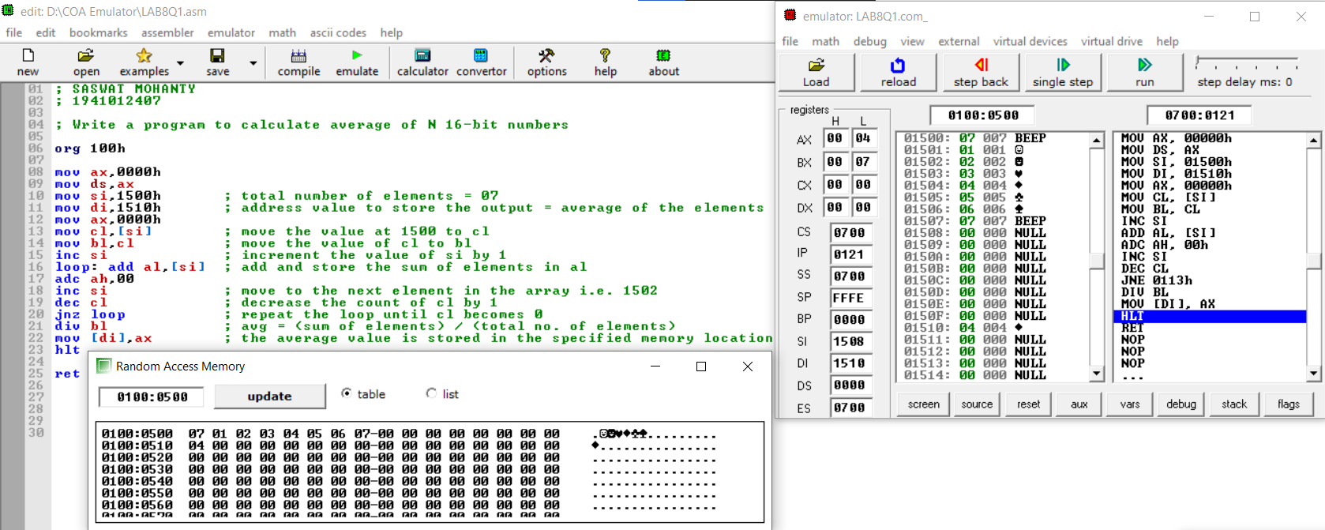

**Conclusion:**

It can be concluded to determine the largest number in an array when dry run and executed in system found to be same. Thus, the program to determine the largest number in an array was executed.

**IV. POST LAB:**

**What is the maximum internal clock frequency of 8086?**

The maximum internal clock frequency of8086 is 5MHz.

**List few applications of microprocessor-based system.**

The use of microprocessor in toys, entertainment equipment and home applications is making them more entertaining and full of features. The use of microprocessors is more widespread and popular. Now the Microprocessors are used in:

* Calculators
* Accounting system
* Games machine
* Complex Industrial Controllers
* Traffic light Control
* Data acquisition systems

**Briefly explain the following instructions of 8086:**

1. **JMP b) JZ c) JNZ d) JC e) JNC**
2. **JMP: -** Used to jump to the provided address to proceed to the next instruction.
3. **JZ: -** Used to jump if equal/zero flag ZF = 1
4. **JNZ: -** Used to jump if not equal/zero flag ZF = 0
5. **JC: -** Used to jump if carry flag CF = 1
6. **JNC: -** Used to jump if no carry flag (CF = 0)